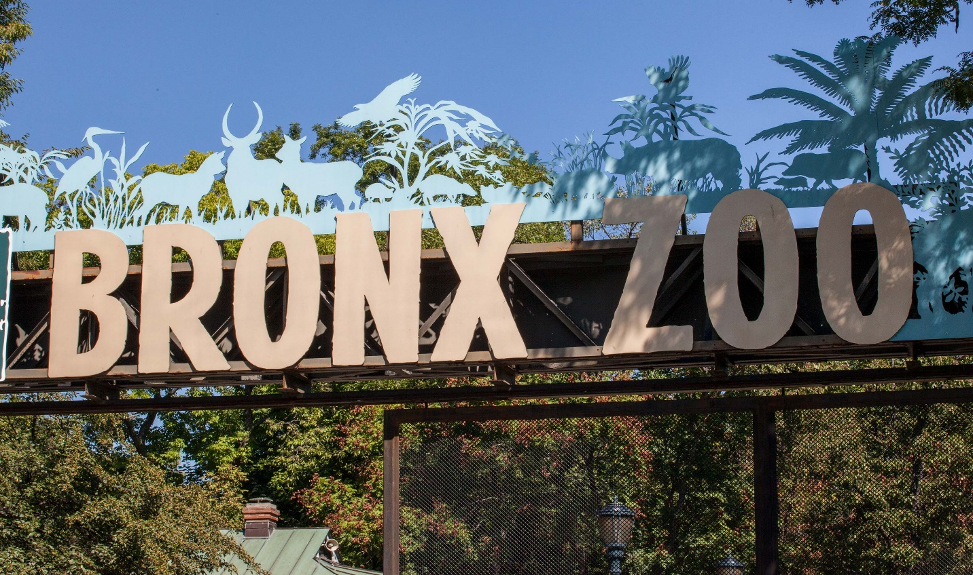

About Bronx Zoo Park

What is Bronx Park Zoo? and where is located established?The Bronx Zoo offers a variety of experiences for families, individuals, and groups. Here's an overview of the zoo's timing, special recommendations for family and ladies' visits, and some details about its animal exhibits and gardens.

Opening & Closed Timings

Monday to Friday: 10:00 AM - 5:00 PM

Saturday and Sunday: 10:00 AM - 5:00 PM

These times can vary depending on seasons, holidays, and special events. It's recommended to check the Bronx Zoo's. He Children's Zoo is a must-visit for families with young kids, where children can interact with farm animals and learn about wildlife in a hands-on way.

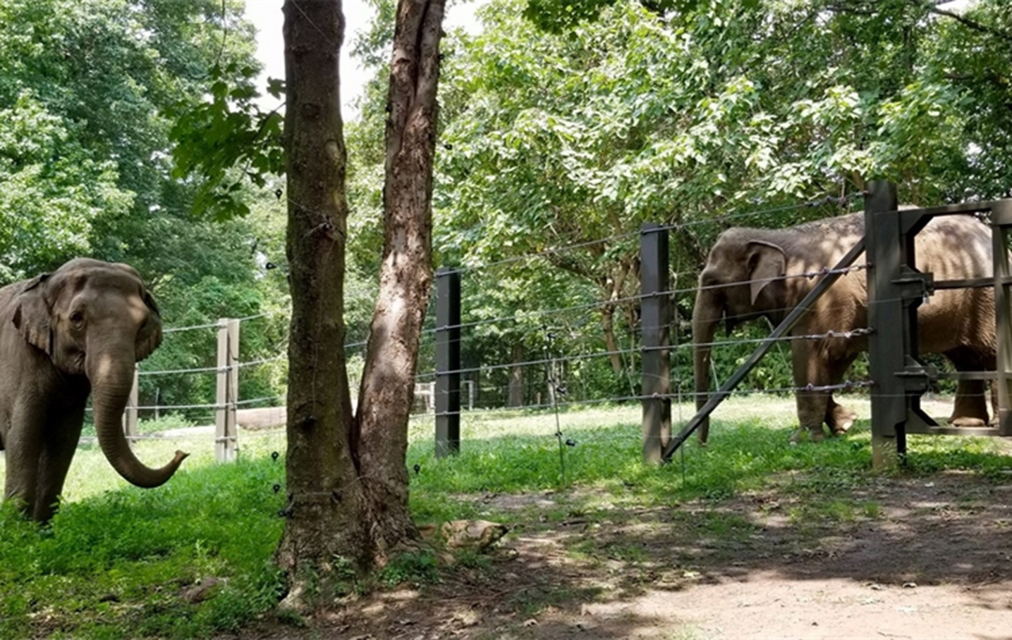

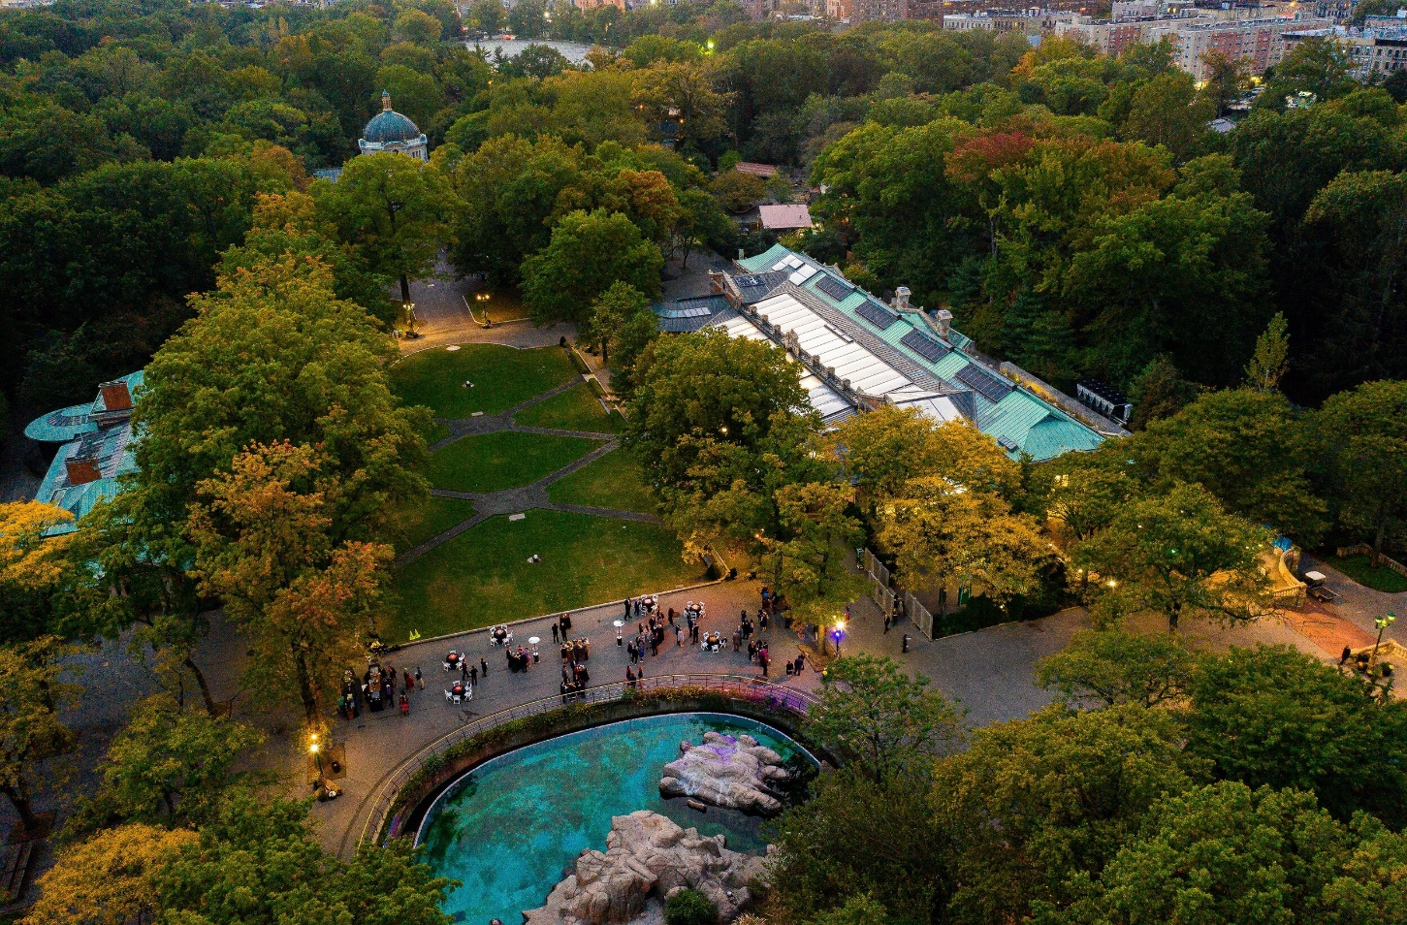

Animals List

The Bronx Zoo, located in New York City, is one of the largest and most well-known zoos in the United States. It is home to more than 6,000 animals representing over 700 species.

Notable exhibits include:

Lions

Kangroo

tigers

snow leopard

Panda

Deer

Gorillas

white elephant

Monkeys

Address & Contact

Address: 2300 Southern Blvd, Bronx, NY 10460, USA, United States. For questions related to visiting, opening times, directions, accessibility, or other general information, you can visit their [Support Centre](https://bronxzoo.org).

Email: For specific enquiries

you can fill out the contact form available on their ( info@wcs.org).

Phone: For urgent enquiries, you can call their Supporter Contact team at +1 718-367-1010.

For the most accurate and up-to-date information, it's recommended to visit the [official Bronx Zoo website](https://bronxzoo.org).